Orators Report
on the 8th Degree
Intendant of the Building
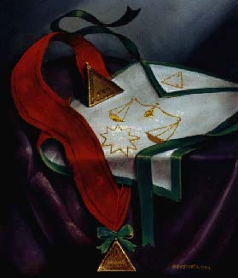
Oct 3, 2012

The apron of the 8th Degree is white, lined with red and bordered with green; in the center is an embroidered nine-pointed star and over that a balance. On the flap is a triangle, with Phoenician letters at each angle.

Bremerton Valley of the Scottish Rite

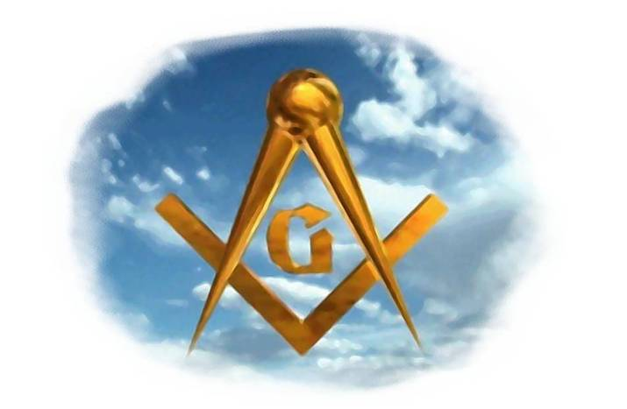
The Legend: The Blue Lodge 3rd degree is based on the legend of Hiram. This legend loosely has its historical basis in 1st Kings 4-7 and 2nd Chronicles 2-4. The Rites are based largely upon the Hiramic legend that follows after Hiram Abiff's death.
The legend of this degree portrays the events following Hiram's death. Since the period of mourning has expired, King Solomon wishes to continue work upon the Temple. The drama focuses on a solution to the problem posed by Hiram's untimely murder.
In the degree, King Solomon appoints five Intendants of the Building to administer the workmen of the various crafts.
The Setting: The site is the Temple of Solomon, under construction.
The Ritual: During the reception, the Master represents King Solomon; other officers assume the names of Tsadoc, Ahishar (Treasurer), King Hiram of Tyre, and workmen. King Solomon seeks the counsel of King Hiram to solve the problem of how to complete the Temple but Ahishar offers the solution. The Master Hiram enjoyed communicating the arts and sciences he learned in Egypt and the East to a group of young men who were eager to learn. Hiram believed these young men would be able to take his place. The Master's delight in transmitting his knowledge teaches us the importance of education to maintain cultural continuity. Ahishar suggests that Hiram's favorites share the responsibility to finish the Temple.
The candidate, as Yehu-Aber, along with the four others, is told that to become an Intendant of the Building he must not only be charitable and benevolent, he must learn the social and moral philosophy of Masonry. He is to view himself as the almoner of God's bounty, recognizing all men as his brothers. Since we no longer work in the operative craft, the Intendant of the Building must labor in human quarries promoting works of charity and benevolence.
The candidate is invested with the cordon, jewel, and emblem of the degree. The apron's three colors, white, red, and green, teach the candidate to conform to the purity of morals and zeal for the service of Masonry.
The Lecture: The province of Masonry is to teach a path to all forms of truth moral, political, philosophical and religious. The political lessons of the degrees through the 8th, are disclosed. A system of government to which man should aspire requires:
4th, 5th, 6th: An enlightened citizenry,
7th: An independent judiciary,
8th: An economic order based on capital and labor.
In the performance of the work, whatever it is, always practice the rules of Benevolence and Charity. Never deal harshly with those in your employ, or those with whom you labor. Do not make false, unjust, or unreasonable claims against them. Aid him and his family, recognizing all mankind as your brothers. Capital and labor must not be adversarial, but complementary, and respectful. They must cooperate to produce harmony. This provokes reflection in respect to the necessity of an elective and independent legislature.
The degrees of this Rite are not intended for those satisfied with mere ceremonies and uninterested in the depth of wisdom buried beneath the surface.
When you become imbued with the morality of Masonry, and it is familiar to you, then be prepared to receive its lofty philosophical instruction. Step by step men advance towards Masonic perfection. Each Masonic Degree is a development of a particular duty, and in the 8th you are taught charity and benevolence, to be an example of virtue, to correct your own faults, and to endeavor to correct those of your Brethren. And beyond your Brethren, extend your charity to the world at large.

THE MORAL TEACHING of this degree impresses upon the candidate the futility of advancing unless the lessons already taught have been carefully considered. The jurisprudence, learning and morality of Masonry and not merely the work and ceremonies should have our most profound thought and attention. The mission of Masonry is to seek after Light and we should consider the earthly life of ours a field for noble action, the beginning of heaven and a part of immortality. This Degree teaches us that we have high duties to perform and a high destiny to fulfill on this Earth. We should love this Earth as the garden on which the Creator has lavished such miracles of beauty, has made it the dwelling place of the wise and the good, the place of opportunity for the development of the noblest passions, the tenderest sympathies and the loftiest virtues.
The mission of Masonry is to teach and follow a path to all forms of truth: moral, political, philosophical and religious.
DUTIES: Be benevolent and charitable.
LESSONS: Benevolence, Charity, and Honest Labor
FOR REFLECTION: Knowledge without its application is of little, or no value.
IMPORTANT SYMBOLS: Triple triangle, nine pointed star, the colors crimson, green and white.
The apron is white, lined with red and bordered with green. The three colors white, red and green, the chief symbolic colors of Scottish Rite Masonry, teach us to imitate the purity of morals and zeal for the service of Masonry which have made our deceased Master immortal in the recollection of men.
The jewel is a gold delta. On one side is engraved the Samaritan word for “Freeborn” and on the other: “Our only God, chief and source of all”.

Adapted from the Spanish version of Rex R. Hutchen’s book A Bridge to Light

